Musical Keys
Recruitment, Induction and Adults code of Conduct Policies

Section 1: Safer Recruitment Policy (Rev Jan 2022)
This Policy sets out the Steps to Safer Recruitment.

We actively seek to keep the people we support as safe as possible. To achieve this, we apply safeguarding principles and protocols to the employment or volunteering of the people who represent our charity and who may work with children, young people and vulnerable adults. Our protocols include:

Defining roles

We will consider the tasks and skills necessary for the job or voluntary position and what kind of person is most suited to the job. We will list the essential and desirable qualities, qualifications and experience for the role to decrease the eligibility of unsuitable candidates.

Selection criteria

We will only select people who meet the essential criteria for the role. We will insist on adherence to our ‘adults code of conduct’ which sets out how we expect adults to behave around children, young people and vulnerable adults.

Recruitment publicity

Vacancies will be advertised in appropriate publications, websites etc and we will specifically target resources which may provide us with the best potential candidates. We will ensure any advert contains a commitment to safer recruitment and safeguarding children, young people and vulnerable adults.

Written application form

We will ask for a written application form or comprehensive CV which includes personal details such as name, past names, date of birth; past and current work/volunteering experience. It should also include explanation of all gaps in employment. Applicants should also provide current and recent addresses for the past 5 years.

Written Declaration

In all instances where people may be working with vulnerable adults or children we will ask for a DBS certificate. Candidates may be able to start work prior to obtaining the certificate as long as there is no potential for them to be working with children or vulnerable adults without supervision.

Identification

We will ask for photographic documentation to confirm identity, such as passport or driving licence and a utility bill that contains their address.

Qualifications

We will ask to see the original documents.

Interview

We will always try to interview face to face and preferably with at least two representatives of Musical Keys, however, we may sometimes need to interview via an internet video call. We will discuss with the applicant information contained in their form and to explore their attitudes towards working with children, young people and/or vulnerable adults. This also provides an opportunity to discuss our child protection and Safeguarding Vulnerable Adults policies to ensure that the applicant has the ability and commitment to meet the standards required.

We will talk about the application including:

- Areas in which more details are required
- Gaps in employment history
- Vague statements or unfamiliar qualifications
- Frequent changes of employment
- Any other anomalies or discrepancies to be pursued
- Motivation for wanting to work with children and/or vulnerable adults

References

Two written references must be obtained and one must always be from the current or most recent employer. If references are not available a risk assessment will need to be carried out to determine the suitability of the candidate.

DBS Checks

We will always seek to gain DBS disclosures as appropriate to the role. When the results of the DBS check and all recruitment checks have been completed and we are satisfied the applicant is suitable for the role employment will be confirmed.

This policy will be reviewed every three years.

Policy agreed and adopted by Board of Trustees 10th August 2015

Signed …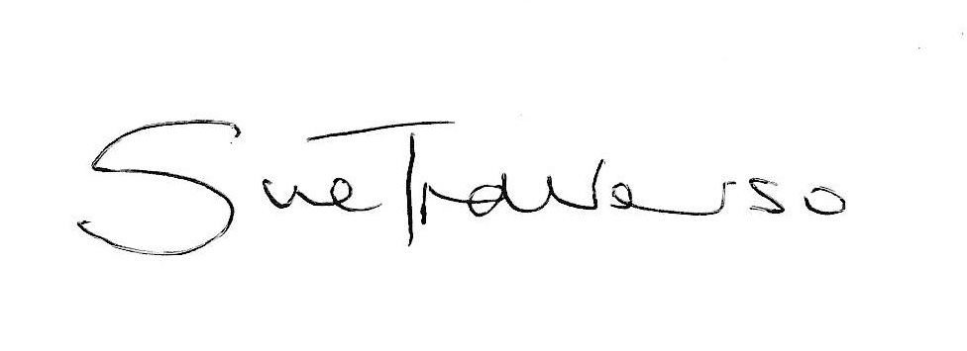………
Chair of Musical Keys Board of Trustees

Reviewed: 15 sept 2021
Amended: Feb 2022

Section 2: Induction.
Musical Keys undertakes to carry out an induction of all staff and volunteers within the first 6 months of their start date to ensure they understand their roles and responsibilities. On successful completion of their induction staff and volunteers will:

Understand their roles and have been equipped with a good degree of knowledge and skills to carry out those roles to a high standard.

Have shown competency and confidence at carrying out the tasks and responsibilities of their post.

Have read and understood all Musical Keys policies, procedures and protocols, including incident recording, health and safety, safeguarding and first aid arrangements.

Have a plan in place for continuing professional development, including Safer Programme Child Protection Awareness Raising Training and other training that will build on existing competencies or provide opportunities for new ones.

Additionally, all staff will need to have discussed the following policies and procedures with a senior member of staff at Musical Keys who will ensure a good level of comprehension has been met:
• Child Protection Policy
• Code of Conduct
• Confidentiality Statement
• Complaints Procedure
• Managing Allegations and “Whistle Blowing” Statement
• Disciplinary and Grievance Procedure

Staff / volunteers will meet with a supervisor representing Musical Keys at least every 4 to 6 weeks to discuss things such as difficulties or achievements, future goals, specific tasks, continuous professional development, implementation issues etc. Minutes of these meetings should be taken and agreed by both supervisor and supervisee.

Section 3: Codes of conduct

Adult’s code of conduct

Purpose
This code outlines the conduct Musical Keys expects from anyone working for, volunteering or representing us in any capacity when working with children or young people. This includes employees, freelancers, trustees, agency staff, interns, students on work placement and anyone who is undertaking duties for our charity, whether paid or unpaid.

This code provides a point of reference to help protect children, young people and vulnerable adults from abuse and reduce the potential for incidents or misunderstandings between the people we work with and the people who represent us.

Musical Keys is responsible for making sure everyone taking part in our services has seen,
understood and agreed to follow the code of behaviour, and that they understand the consequences of inappropriate behaviour.

Adults working, volunteering or representing Musical Keys in any capacity are expected to adhere to the following code of conduct:

- Treat all children, young people and vulnerable adults with respect and dignity by listening to, valuing and taking children’s contributions seriously, actively involving them in planning activities wherever possible and respecting a young person’s right to personal privacy as far as possible.
- Ensure that the welfare and safety of children, young people and vulnerable adults is paramount at all times by providing a safe environment for children, young people and vulnerable adults, ensuring equipment is used safely, modelling good behaviour for children, young people and vulnerable adults to follow by acting in a professional way, liaising openly with parents and carers in the best interests of the child or young person and adhering to Safer Working Practices at all times.
- Listen to, and act upon, any disclosures, allegations or concerns about the welfare of children by referring to Musical Keys safeguarding policies.
- Attend Safer Programme training every 3 years.
Unacceptable behaviour
When working with children, young people and vulnerable adults, you must not:
- Allow concerns or allegations to go unreported
- Take unnecessary risks
- Smoke, consume alcohol or use illegal substances
- Engage in behaviour that is in any way abusive, including having any form of sexual contact with a child or young person.
- Let children, young people and vulnerable adults have your personal contact details (mobile number, email or postal address) or have contact with them via a personal social media account.
- Act in a way that can be perceived as threatening or intrusive
- Patronise or belittle children, young people and vulnerable adults
- Make sarcastic, insensitive, derogatory or sexually suggestive comments or gestures to or in front of children, young people and vulnerable adults.

Name:
Signed:
Date:

Signed on behalf of Musical Keys:
Sue Traverso
Chair of Trustees.
Revised Feb 2022

